Bacterial Invasion

5-Part Plan Title: | Bacterial Invasion
Engineering Grand Challenge Covered: | Engineer Better Medicines/ Engineer the Tools of Scientific Discovery
Fellow Contributor(s) / Group Number: | Alexa Choy
Grade Level(s): | 6-8

5-Part Make-It-Happen Plan

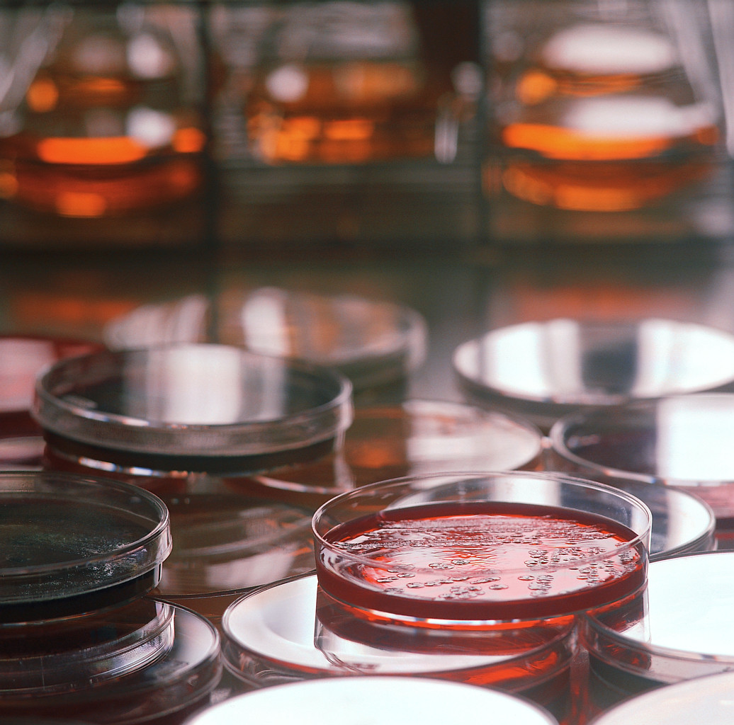
Copyright © 2004 Microsoft Corporation, One Microsoft Way, Redmond, WA 98052-6399 USA. All rights reserved.

- Learn It: Students will learn about the different types of bacteria that are commonly found on your hands or on items that you regularly come in contact with (phone, desk, keyboard, etc.). They will research the active ingredients in different types of hand sanitizers and soaps as well as analyzing natural alternatives that also possess antibacterial properties, such as garlic, apple cider vinegar, and various types of herbs. Students will learn to answer questions such as, what compounds are responsible for their anti-microbial effects? What mode of action do these chemicals take in killing bacteria? Are these agents effective against viruses as well? Why or why not?

- Do It: Students will take a sterile cotton swab and lightly wet one end in distilled water. Next, they will thoroughly swipe the swab along the palm of their hand or desk. Next, they will spread this end of the swab onto agar medium (in a petri dish), covering the entire surface. This process will be repeated for an additional 2 plates.

Students will read about the antimicrobial effects of the natural compounds that they may likely have in their house: garlic, lemon juice, salt water, apple cider vinegar, peppermint oil, turmeric (These are just a few examples. Many other natural compounds contain antibacterial properties and could replace the ones listed here. Students can each bring 1 or 2 items to class). Students in groups will then decide which compounds might be the most effective in killing the bacteria and will then combine those compounds into a small cup provided to create an all-natural antibacterial solution. Using a plastic pipet, a few drops of their solution will be placed on the center of one of the previously swiped plates without spreading it. Using another pipet, students will pipet a few drops of the synthetic antibacterial soap/hand sanitizer on a different plate. Again, it is important for student to not spread the soap over the entire surface. Lastly, students will leave another plate with just the bacteria and no treatment. After setting up these conditions, students will place parafilm on each of the three petri dishes and leave them in a warm place for 1-2 days. After the initial set-up, students will be asked to make predictions about what each of the three plates will look like after 2 days. Students will need to contemplate which plate will have the most bacterial growth inhibition? Which will have the least?

After the 1-2 day incubation period, the plates will be observed. In order to quantify the effects of the natural compounds used, students will hold each plate up to the light and search for zone of inhibitions (no growth). If there is a zone then they can use a ruler to measure its diameter. These values will be compared for each of the other three plates. Lastly, the average diameter of the zone of inhibition for all of the groups in the class for each treatment group (control, soap, natural compound) will be calculated.

- Share It: Students will explore the global implications of their results. They will contemplate questions such as: How can people living in third world countries without access to the same range of antibacterial soaps/hand sanitizers disinfect their hands, household items, etc.? How/why might your natural antibacterial solutions be better for your health? How can the overuse of antimicrobial agents lead to drug-resistant infections?

Another potential activity is for students to design the packaging for their natural antibacterial sanitizer. They should include the ingredients list, a name for their product, and some kind if tagline (based on their data, e.g. “More effective than X Brand Antibacterial Soap”). Students can then vote to see which group came up with the most potentially successful design.

- Create It: Students will discuss potential inconsistencies in the experiment as well as the probability of repeating it using different antimicrobial agents. Specifically, it would be important to experiment with different combinations of natural ingredients, new ingredients, and/or different brands of antibacterial soaps.

- Teach It: Students will share their results with other groups in the class. By comparing and analyzing the results, students will determine which solutions worked better than others. Special attention will be put on looking if groups testing the same solution received similar results. If not, then students will hypothesize why there was high variability.

