Can You Handle the Pressure?

5-Part Plan Title: | Can you handle the Pressure?
Engineering Grand Challenge Covered: | Engineering Tools of Discovery
Fellow Contributor(s) / Group Number: | Rebekah Johnston
Grade Level(s): | 3-5

5-Part Make-It-Happen Plan

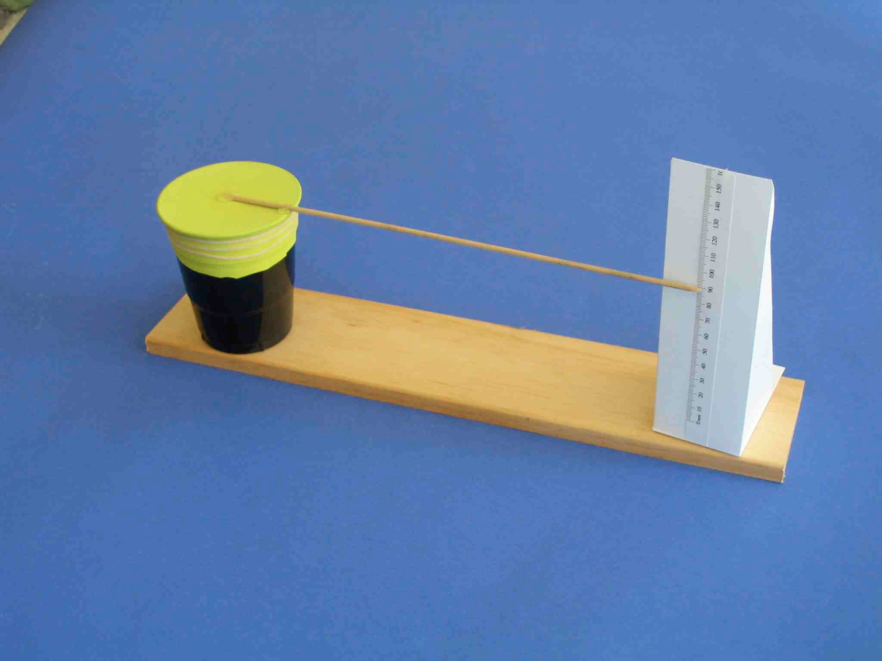

- Learn It: What do you associate with different types of weather? Students will brainstorm various weather patterns and potential reasons the weather changes. Students will also discuss what causes cold or warm fronts to move across the globe. Instructors should explain how atmospheric pressure relates to how heavy the air around us is. It is important for students to understand that air pressure is a force exerted on us by air molecules. Consequently, the large space between air molecules can be compressed to a smaller volume. This compression is correlated to high pressure that is associated with cooler air and clear or calm weather. Meanwhile low pressure is correlated to thunderstorms, warmer weather and high winds.

- Do It: Students will build a device that can measure the air pressure then they will analyze the measurements to see how this relates to the weather. This simple barometer will be built by stretching a balloon over a jar then placing a straw over it to act as a measuring needle.

- Share It: Students will explore other weather instruments. For each instrument, students will contemplate the following questions: What do they measure? What can you tell from the measurements? In addition, the Barometer will be used to make predictions about the future weather patterns.

- Create It: Depending on the number of glass jars, students will get in groups or work as individuals such that everyone has a glass jar to work with. The following materials will be passed out: balloon, rubber band, tape, straw, paper, pen/pencil, scissors, and ruler. Students will blow up a balloon then hold for 10 seconds (or more), and then release the air. Next, the entire neck of the balloon will be cut off. The lid of the jar will be removed and placed to the side such that the balloon can be placed over the mouth of the jar and secured with a rubber band. The balloon should be very tight with no wrinkles or excess material. Students will tape the end of a straw to the center of the balloon. It is very important to use straws that do not have a section that bends; if those straws are being used then the bending part should be cut off. Beside the jar, a piece of paper that is aligned to the bottom of the jar will be placed in order to mark where the straw lies. Students will then proceed to make ¼ inch increments one inch above and below this mark for the scale measurement. (See photo above) Lastly, the current atmospheric pressure will be checked and the middle line of the barometer will be marked to be that pressure.

- Teach It: Based on the activity, students will discuss why measuring and understanding the weather phenomena around us is important. They will also contemplate how a better understanding of weather can improve our lives as well as how better measuring tools can improve our understanding of weather. Students will record the pressure using the barometer for the next ten school days and the corresponding weather. At the end of the ten days, they will discuss what happens to the weather when the pressure was high or low.

