Can You Handle the Pressure? Activity Template

5-Part Plan Title: | Can you handle the Pressure?
Engineering Grand Challenge Covered: | Engineering Tools of Discovery
Fellow Contributor(s) / Group Number: | Rebekah Johnston
Grade Level(s): | 3-5

- Subject Area(s): Science, Technology, Math
- Associated Unit or Lesson: None
- Time Required: 30 min
- Group Size: 30 (with students in pairs or, if materials allow, by themselves)
- Expendable Cost per Group: ~$90.00
- Summary: Weather is a phenomenon that impacts everyone’s daily lives. Understanding and correctly measuring the various forms of weather is important to understanding how ones local climate operates and how climates vary across the globe. Atmospheric pressure is an important component of weather that is often overlooked because it is unseen and hardly felt. In this lesson, students will learn how to make a barometer and what the various readings may mean in terms of current and future weather patterns.
- Engineering Connection: Tools of measurement are very important for engineering. Engineers build and design measuring tools as well as use them to test designs for safety and validity. Understanding the function and design of basic engineering tools can lead to a greater understanding and interest in improving the measuring tools we currently use.
- Key Search words: pressure, barometer, atmosphere, atmospheric pressure, air pressure weather, measure, tool, climate
- Educational Standards: See attached standards grid for a complete mapping to all pertinent STEM standards.
  - Common Core Math Standards: 3.NBT.1, 3.NBT.2, 3.MD.4, 4.NBT.3, 4.NBT.6, 4.MD.1, 5,NBT.3, 5.NBT.4, 5.MD.1, 5.MD.2
  - NC Essential Science Standards: 5.E.1.1, 5.E.1.2, 5.E.1.3
  - NC Engineering Connection Standards: 1.2, 1.7, 8.1
- Pre-Requisite Knowledge: None
- Learning Objectives (After this activity, students should be able to):
  - Build a barometer from a glass jar
  - Understand what atmospheric pressure is and its affect on weather systems
  - Gather data on daily pressures and make inferences about current and future weather systems
- Materials List: [number in parenthesis indicates amount to complete one project]
Jars (1), Balloons (1), Rubber Bands (1), Scissors (1), Ruler (1), Straw (1), Tape, pen/pencil, paper
- Introduction / Motivation: What does air feel like? Does it feel light? Heavy? Wet? Dry? How can you tell if the air around you today is different from the air around you yesterday? One way is by measuring the pressure of air or atmospheric pressure. Atmospheric pressure is a measure of the amount of air around us. When the pressure is high, it means there is more air around us than normally and the air is “heavier”. When the pressure is low, it means there is less air around us and the air is “lighter”. The earth wants all the pressures around the world to be equal. The differences in pressure, which can be caused by differences in temperature, create wind because the low pressure sucks air from the high pressure to try to make everything even.
Why do we need to learn about air pressure and measure it? Because air pressure can tell us a lot about the weather we are about to experience. If the pressure is low, the weather is likely to be stormy and tornados could potentially occur. If the pressure is high then the weather is likely to be clear, calm and it probably won’t rain. Knowing what the air pressure is can help people plan their days better and keep people informed about potentially dangerous weather systems.
- Vocabulary / Definitions:
- Atmospheric pressure - the pressure exerted by the earth's atmosphere at any given point, relating to the mass of the air and gravity
- Weather – the state of the atmosphere relating the wind, temperature, precipitation etc.
- Barometer – an instrument used to measure air pressure
- Weather front – a boundary separating two masses of air of different densities
- Procedure:
- Before the Activity – The instructor will acquire all the materials and give an introduction on weather instruments and air pressure.
- With the Students - Depending on the number of glass jars, students will get in groups or work as individuals such that everyone has a glass jar to work with. The following materials will be passed out: balloon, rubber band, tape, straw, paper, pen/pencil, scissors, and ruler. Students will blow up a balloon then hold for 10 seconds (or more), and then release the air. Next, the entire neck of the balloon will be cut off. The lid of the jar will be removed and placed to the side such that the balloon can be placed over the mouth of the jar and secured with a rubber band. The balloon should be very tight with no wrinkles or excess material. Students will tape the end of a straw to the center of the balloon. It is very important to use straws that do not have a section that bends; if those straws are being used then the bending part should be cut off. Beside the jar, a piece of paper that is aligned to the bottom of the jar will be placed in order to mark where the straw lies. Students will then proceed to make ¼ inch increments one inch above and below this mark for the scale measurement. (See photo below) Lastly, the current atmospheric pressure will be checked and the middle line of the barometer will be marked to be that pressure. Students will record the pressure using the barometer for the next ten school days and the corresponding weather. At the end of the ten days, they will discuss what happens when the pressure is high or low.
- Cleanup – Students will dispose of balloon scraps and other trash. It is advised to save the jar lids for future projects if space allows.
- Classroom Testing Information: Students will take measurements of the air pressure using the barometer over ten school days. They will then analyze these results to see how they correlate with the weather.
- Safety Issues: When handling the glass jars, be sure to have one person holding the jar steady while the other is securing the balloon and rubber band on the top. Additionally, scissors are being used and caution should be taken when handling scissors.
- Troubleshooting Tips: If the balloon won’t stay flat on the surface of the jar, have one person hold the balloon stretched across the mouth of the jar and pulled slightly down and have a second person wrap the rubber band around the jar.
- Investigating Questions:
- What is air pressure?
- How does air pressure correlate to the weather?
- What causes low air pressure? High air pressure?
- Assessment: None
- Contributors: Rebekah Johnston
- Supporting Program: Duke Boeing Grand Challenge K12 Outreach Fellows Program
- Documentation for use of Photos or Images:

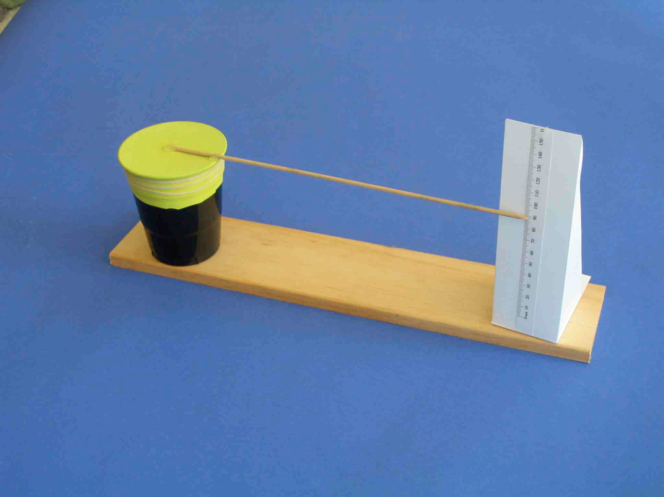
http://www.sci-experiments.com/barometer/barometer.html

- Figure #1
- Image filename: Barometer
- ADA description
- Source/Rights: Copyright
- Caption: Constructing an Aneroid (without fluid) Barometer

